 **19 June 2015** **The Weekly Bulletin of Rotary Club of Kathmandu Mid-Town** **bc-45/6.015**

|  |
| --- |
|  |

District: 3292 Web:www.rotarymidtown.org.np Club Id: 26776

**JUNE IS THE ROTARY FELLOWSHIPS MONTH**

***June is designated Rotary Fellowships Month to recognize the importance of international fellowship and goodwill among Rotarians with similar recreational and vocational interests, promote increased participation***

***in fellowships, and increase understanding of this program.***

***The RI Board encourages these groups to celebrate Rotary Fellowships Month through projects, activities, and events.***

Club’s Weekly Meeting # 1283 on 12 June:

Extracts of the Minutes # 1283

“1. Pres Kul Chandra called meeting #1283 to order.

“3. Pres Kul Chandra welcomed members and guests. Guests: Judith Amtzis and Dr David Thomas (Aus).

”7. Speaker Dr Aruna Upreti was introduced by Sec Isa. Dr Upreti spoke on the topic of 'cultural practice, menstrual health, and hygiene. Dr Upreti gave several graphic examples of how women in the west of Nepal are subjected to the archaic practice of Chhaupadi (exclusion from normal society during the time of their menstrual period) and that to a lesser extent this exclusion is still practiced even in the homes of educated folks elsewhere in Nepal. Much ignorance and superstition still surrounds this topic. After a lively Q&A Rtn Dr Buddha gave the vote of thanks.

”8. Information sharing:

> PP William Ma informed that PP Rtn Chris Etienne of District 6290 has sent a donation of US$ 4444.35 to our Club

Account to aid in the Quake Relief works;

> Sec Isa informed that to date some 46K $USD has been received from Clubs and well-wisher worldwide;

> RC KTM Mid-Town donated 30,000Nrs to our Exec Sec SK Dahal for rebuilding of his home after the earthquake;

> Mid-Town donated 84,544 NRs to Mr Dharma Lal Shrestha of the Janta School in Tistung to continue with rebuilding and rehabilitation at the school;

> TRF Chair PP Komal reported that this year the donation to the Rotary Foundation from Mid-Town totalled approx $4K USD. There is still time to give;

> PP Mani informed about the District level trainings that would be taking place this weekend, the District Training Seminar, The Grants Management Seminar, and the Membership Seminar. Members who need to attend please do so;

> PP Ambica informed about progress on the biogas project. Rtn Pabitra informed that to dat 10 units are functional. A written report (in German) with photos is forthcoming;

> Pres Kul reminded all that we all have an obligation to complete reporting on projects.

“9. Statistics of the meeting: Members present: 24”

# Weekly Meetings and Programs :

|  |  |  |
| --- | --- | --- |
| Date | Program/ Speaker | Topic of Presentation |
| 19 June | Ms Chandani Joshi. |  |
|  |  |  |

Weekly Meeting on Friday, 19 June:



Ms. Chandni Joshi, Gender, Rights and Policy Specialist: With 50 years of working experience, Ms.

Chandni Joshi's name is synonymous with gender, rights and macro policies in Nepal and other South

Asian countries alike. Envisioning all her life of a gender just world, she has consistently strived for a

world of equal opportunities, equal choices and equal recognition of work, of both women and men.

From a Lecturer at Padma Kanya College to the Regional Programme Director of UNIFEM (United

Nations Development Fund for Women) for South Asia, Ms. Joshi's professional journey has given her

innumerous challenges at national, regional and global level which have enhanced her capabilities and

evolved her into a powerhouse of knowledge in diverse issues. She is an inspiration to her peers and

younger generation, and an asset to her nation Nepal.

Ms. Joshi is the founder of the successful development model of the Production Credit for Rural Women programme, which was replicated in the 49 districts of Nepal and which today covers all 75 districts. She has travelled to 65 districts of Nepal for her fieldwork on PCRW and Jaycees.

The awards and decorations that she has been honoured are Lifetime Achievement Award Felicitated by Shanti Malika in 2013,National Women’s Commission in 2012, Didi Bahini for her Extra-ordinary Contribution for Social Mobilization and Women's Empowerment in 2011, Lifetime Achievement Award by the President of Nepal in 2009, Lifetime Achievement Award from PAAN (Public Administration Association of Nepal) in 2007; Social Service Award from SSNCC in 2007, Dream Team Award by UNIFEM in 1999; Prabal Trishakti Patta in 1989, SAARC medal in 1988, the Gorkha Dakshin Bahu in 1982, and the Coronation medal in 1974.

Ms. Joshi received her Masters degree in English Literature from Tribhuvan University in 1965, where she taught and was the Head of the Department in English Literature. With diplomas in linguistics, management and communications, she has several publications to her credit.

**Women in Rotary**

The first Irish clubs discussed admitting women as members in 1912, but the proposal floundered over issues of social class.

Gender equity in Rotary moved beyond the theoretical question when in 1976, the Rotary Club of Duarte in [Duarte, California](https://en.wikipedia.org/wiki/Duarte,_California), admitted three women as members. After this club refused to remove the women from membership, in 1978 Rotary International revoked the club's charter. The Duarte club filed suit in the California courts, claiming that Rotary Clubs are business establishments subject to regulation under California's [Unruh Civil Rights Act](https://en.wikipedia.org/wiki/Unruh_Civil_Rights_Act), which bans discrimination based on race, gender, religion or ethnic origin. Rotary International then appealed the decision to the [U.S. Supreme Court](https://en.wikipedia.org/wiki/U.S._Supreme_Court). The Duarte Club was not alone in opposing RI leadership; the [Seattle](https://en.wikipedia.org/wiki/Seattle)-International District club unanimously voted to admit women in 1986. The United States Supreme Court, on 4 May 1987, confirmed the Californian decision. Rotary International then removed the gender requirements from its requirements for club charters, and most clubs in most countries have opted to include women as members of Rotary Clubs.

The change of the second Rotarian motto in 2004, from "He profits most who serves best" to "They profit most who serve best", 99 years after its foundation, illustrates the move to general acceptance of women members in Rotary.

Timeline of women in Rotary … ‘Annex’

**MOU with District 3292 for Building 200 Temporary Shelters**

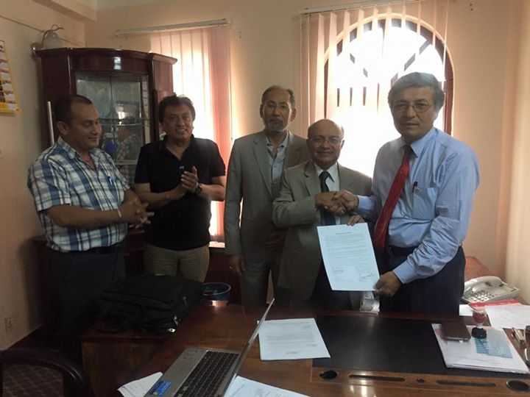

RC Kathmandu Mid-Town President Kul Gautam exchanging MOU with District Governor Rabindra Piya on building 200 temporary shelters for earthquake victims. The District has agreed to support matching 100 shelters.

**TOP 25 DESTINATIONS IN THE WORLD**

Travelers' Choice # 1 Destination: Marrakech, Morocco; # 2: Siem Reap, Cambodia; # 3: Istanbul, Turkey;

# 4: Hanoi, Vietnam; # 5: Prague, Czech Republic; # 6: London, UK; # 7: Rome, Italy; # 8: Buenos Aires, Argentina;

# 9: Paris, France; # 10: Cape Town Central, South Africa; # 11: New York City, United States; # 12: Zermatt, Switzerland;

# 13: Barcelona, Spain; # 14: Goreme Turkey; # 15: Ubud, Indonesia; # 16: Cusco, Peru; # 17: St. Petersburg, Russia;

#18: Bangkok, Thailand; # **19: Kathmandu, Nepal;** # 20: Athens, Greece; # 21: Budapest, Hungary;

# 22: Queenstown, New Zealand; # 23: Hong Kong, China; # 24: Dubai, United Arab Emirates; # 25: Sydney, Australia.

*Source:* http://www.tripadvisor.com/TravelersChoice-Destinations

Travel / Tourism

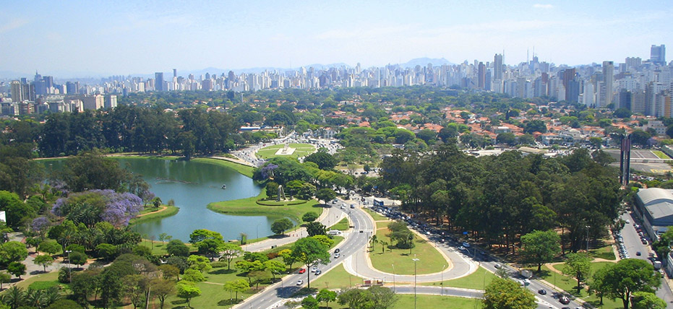

“Travel and change of place impart new vigor to the mind”





*Courtesy: Dr Isabella C Bassignana Khadka*

**A THOUGHT FOR TODAY:**

**[Kindness is a language which the deaf can hear, and the blind can read!](http://www.brainyquote.com/quotes/quotes/b/baruchspin101666.html" \o "view quote)**

On Lighter Side:

**When God Sends You Help Don't Ask Questions!**

Elsie hurried to the pharmacy to get medication, got back to her car and found that she had locked her keys inside.  The woman found an old rusty coat hanger left on the ground.

She looked at it and said, "I don't know how to use this."

She bowed her head and asked God to send her some HELP.

Within 5 minutes a beat-up old motorcycle pulled up, driven by a bearded man who was wearing

an old biker skull rag.  He got off of his cycle and asked if he could help.

She said: "Yes, my daughter is sick. I've locked my keys in my car. I must get home.

Please, can you use this hanger to unlock my car?"

He said, "Sure." He walked over to the car, and in less than a minute the car was open.

She hugged the man and through tears said,  "Thank You, God, for sending me such a very nice man."

The man heard her little prayer and replied,

"Lady, I am not a nice man. I just got out of prison yesterday; I was in prison for car theft."

The woman hugged the man again, sobbing, "Oh, thank you, God! You even sent me a Professional!"

Is GOD great or what !?!

*Courtesy: Dr Isabella C Bassignana Khadka*

“Rotary members worldwide stand together in expressing a profound sadness at the

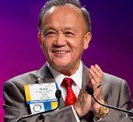

devastation resulting from deadly earthquakes in Nepal. As we mourn the thousands of

lives lost, Rotary joins other international agencies in providing immediate relief to survivors

through our partnership with ShelterBox and mobilizing our expertise to support long-term

recovery and rebuilding efforts throughout the country."

**RI President GARY C.K. HUANG**

## 19 June 2015 The Weekly Bulletin of Rotary Club of Kathmandu Mid-Town bc-45/6.015

**Timeline of women in rotary**

1950**:**An enactment to delete the word “male” from the Standard Rotary Club Constitution is proposed by a Rotary club in India for the Council on Legislation meeting at the 1950 RI Convention.

1964**:**The Council on Legislation agenda contains an enactment proposed by a Rotary club in Ceylon (now Sri Lanka) to permit the admission of women into Rotary clubs. Delegates vote that it be withdrawn. Two other proposals to allow women to be eligible for honorary membership are also withdrawn.

1972**:**As more women begin reaching higher positions in their professions, more clubs begin lobbying for female members. A U.S. Rotary club proposes admitting women into Rotary at the 1972 Council on Legislation.

1977**:**Three separate proposals to admit women into membership are submitted to the Council on Legislation for consideration at the 1977 RI Convention. A Brazilian club makes a different proposal to admit women as honorary members.

The Rotary Club of Duarte, California, USA, admits women as members in violation of the RI Constitution and Standard Rotary Club Constitution. Because of this violation, the club's membership in Rotary International is terminated in March 1978. (The club was reinstated in September 1986.)

1980**:**The RI Board of Directors and Rotary clubs in India, Sweden, Switzerland, and the United States propose an enactment to remove from the RI and club constitutions and bylaws all references to members as “male persons.”

1983-86**:**In a lawsuit filed by the Duarte club, the California Superior Court in 1983 rules in favor of Rotary International, upholding gender-based qualification for membership in California Rotary clubs. In 1986, the California Court of Appeals reverses the lower court's decision, preventing the enforcement of the provision in California. The California Supreme Court refuses to hear the case, and it is appealed to the U.S. Supreme Court.

1987**:** On 4 May, the U.S. Supreme Court rules that Rotary clubs may not exclude women from membership on the basis of gender. Rotary issues a policy statement that any Rotary club in the United States can admit qualified women into membership.

The Rotary Club of Marin Sunrise, California (formerly Larkspur Landing), is chartered on 28 May. It becomes the first club after the U.S. Supreme Court ruling to have women as charter members.

Sylvia Whitlock, of the Rotary Club of Duarte, California, becomes the first female Rotary club president.

1988**:** In November, the RI Board of Directors issues a policy statement recognizing the right of Rotary clubs in Canada to admit female members based on a Canadian law similar to that upheld by the U.S. Supreme Court.

1989**:** At its first meeting after the 1987 U.S. Supreme Court decision, the Council on Legislation votes to eliminate the requirement in the RI Constitution that membership in Rotary clubs be limited to men. Women are welcomed into Rotary clubs around the world.

1990**:** As of June, there are about 20,200 female Rotarians worldwide. The Rotarian runs a [feature on women in Rotary](http://books.google.com/books?id=RDIEAAAAMBAJ&lpg=PP1&pg=PA26#v=onepage&q&f=false).

1995**:** In July, eight women become district governors, the first elected to this role: Mimi Altman, Gilda Chirafisi, Janet W. Holland, Reba F. Lovrien, Virginia B. Nordby, Donna J. Rapp, Anne Robertson, and Olive P. Scott.

2005**:** Carolyn E. Jones begins her term as the first woman appointed as trustee of The Rotary Foundation.

2008**:** Catherine Noyer-Riveau begins her term as the first woman elected to the RI Board of Directors.

2010**:** More than 199,000 women are members of Rotary clubs worldwide, with an increasing number serving as district governors.

2012**:** Elizabeth S. Demaray begins her term as treasurer, the first woman to serve in this position

2013: Anne L. Matthews, a Rotarian from South Carolina, begins her term as the first female vice-president of Rotary International.

2013: Nan McCreadie is appointed as the first female president of Rotary International in Great Britain and Ireland (RIBI).

On Nepal Rotary:

Do you know?

So far eleven Rotary Clubs chartered, or in the process of chartering, in Nepal have been terminated: They are RC Janakpurdham, Nepalgunj, Nepalgunj Mid-Town, Janakpur, Baitadi, Patan South-East, Arniko (Baneswor), Kalaiya,

Kathmandu Elites, Tulsipur, Madhyabindu Kawasoti.

RC of Makwanpur is the newest and 89th Club within RCD 3292.

Rotary extension: Rotary clubs exist currently in 21 districts of the country.

RI Charter: It took 9 months for Tripureswor

While it took 2 days only for Rajdhani